# Lesson 6 – Biodome

# Setting the scene

In this project you will be combining input and output devices on your Arduino. You will be creating a number of circuits using a breadboard which will incorporate two LEDs. You will then use the MKR Env Shield to measure a range of environmental conditions inside of a plant dome. The LEDs will automatically be controlled by the environmental conditions within the dome.

# Success criteria

* Create a circuit using a breadboard
* Create a system to monitor and record environmental conditions within a planted bio dome
* To turn input and output devices automatically on and off depending upon readings taken by a sensor

# Step 1 – Building the LED

You are initially going to connect a bright white LED to the breadboard. You will write code to test that the LED circuit functions as anticipated. A breadboard is used to be able to quickly connect different electrical components. This allows you to test the circuit prior to permanently soldering it together. The circuit diagram below shows different components and how they should be connected. Each of the different components should be pushed into the relevant hole as per the diagram below. On the Arduino the socket which is highlighted in white is the ground. The LED itself is connected to socket 5 on the Arduino. You will notice that the other wire on the other side of the LED is connected to a resistor. The reason for using the resistor is to limit the current flowing through the LED which protects it from burning out.   
A 220 Ω resistor should ensure the LED is quite bright.

You should initially connect the MKR Enviro shield. This will allow you to leave the sensors exposed so that they can accurately measure conditions later in this tutorial.

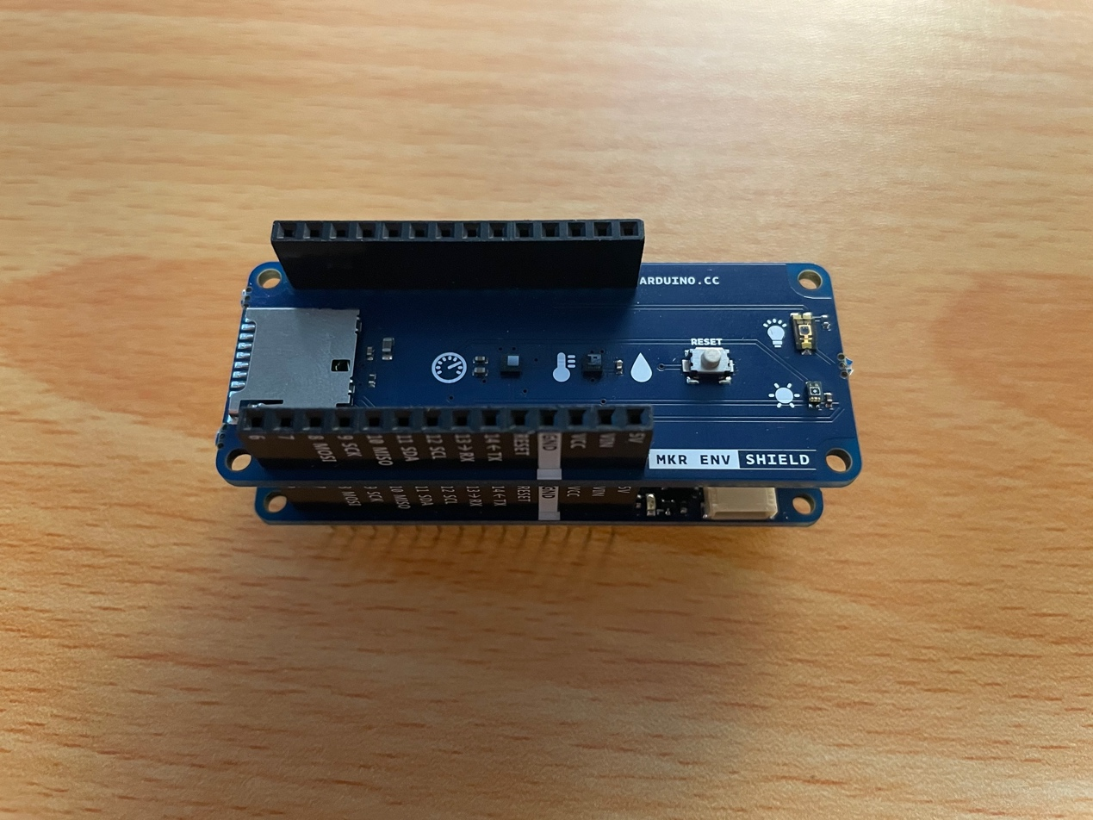

# Pro-tip

Choose the shortest wires possible when wiring up your breadboard. This will keep your circuit as neat as possible.

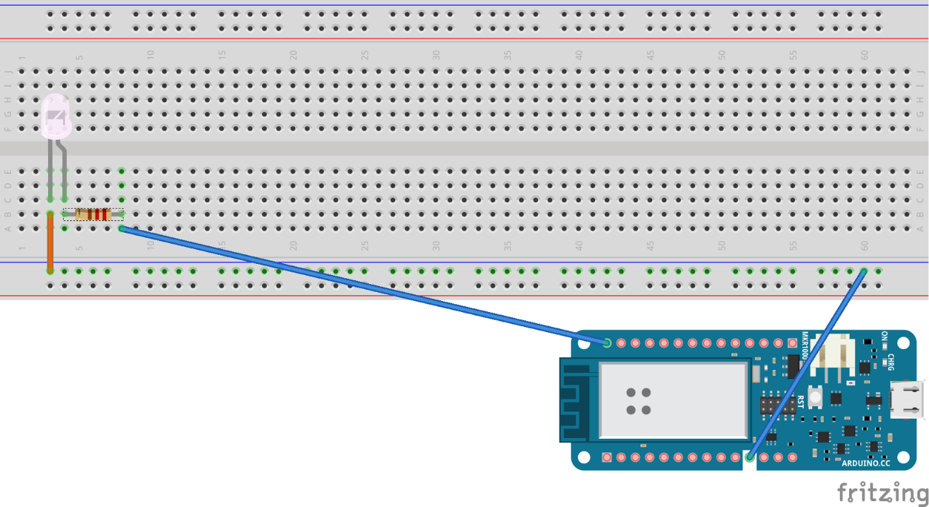

You should then connect the circuit as pictured above.

You are now going to write the code to check that the LED works.

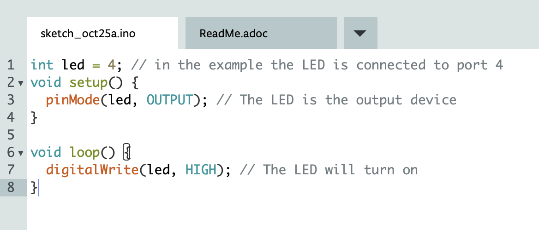

Create a new sketch and then enter the code above. To create a sketch, from the create.arduino.cc editor click on ‘New sketch’:

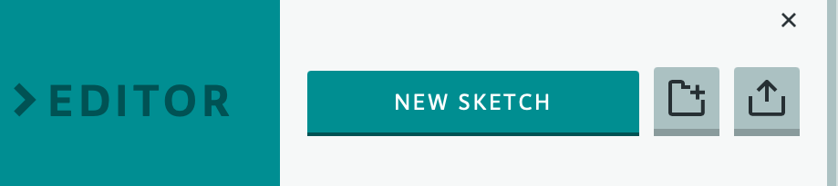

Once you have entered your code, to upload it to your Arduino click on the arrow which points to the right:

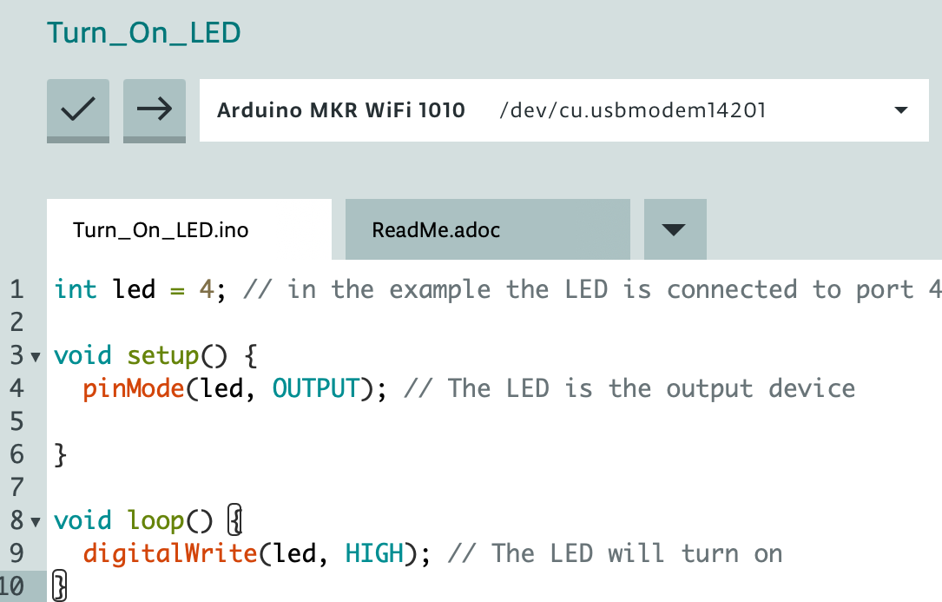

Once you upload it to your MKR1000, the LED will light up.

# Pro-tip

When wiring up a breadboard it worth always testing the output devices using build in example programs to ensure that your breadboard works as expected.

# Step2 – Adding environmental monitoring

You are going to use the MKR Env Shield to monitor the environmental conditions inside the biodome. The shield enables you to monitor temperature, pressure, humidity, UVA, UVB and light intensity.

You are now going to create the code to measure the humidity and temperature.

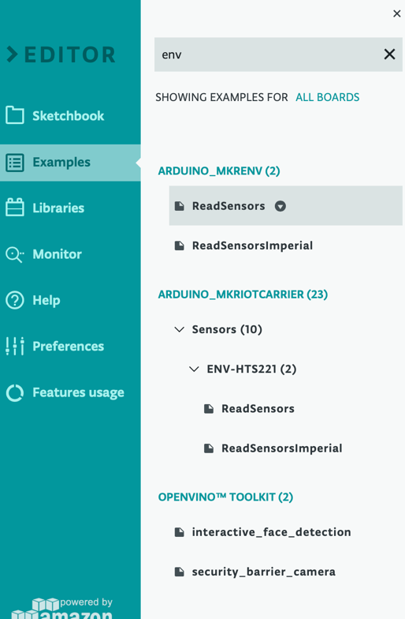

Select examples in the editor and search for ‘env’. You will then see a ReadSensors file under the Arduino_MKRENV section. Open this file and upload it to your MKR1000. You should then click on monitor to view the current readings to check that everything is working as anticipated.

# Adding the data to the Arduino IoT Cloud

You are now going to connect your device to the cloud. Initially you should create a new thing. Navigate to <https://create.arduino.cc/iot/things> and select ‘Create thing’. In our example it has been called ‘New Biodome’.

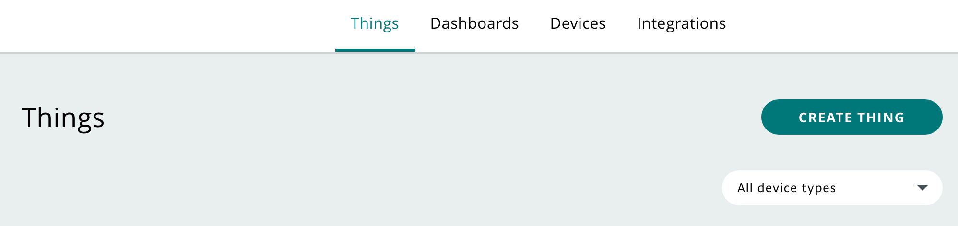

Replace ‘Untitled’ with the name of your thing.

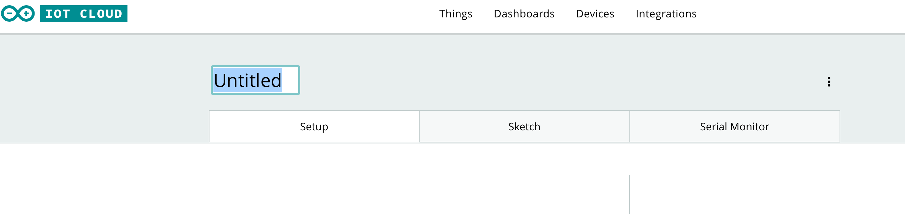

Select the device which contains your program.

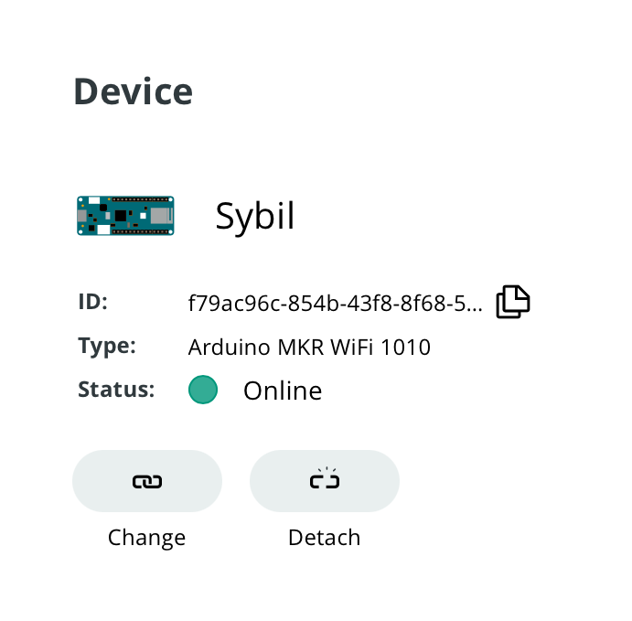

You then need to add several variables to your new thing. These should be called: temperature, humidity, uva, uvb, illuminance and pressure. Each of the properties should be set to a float. Initially select ‘Add variable’.

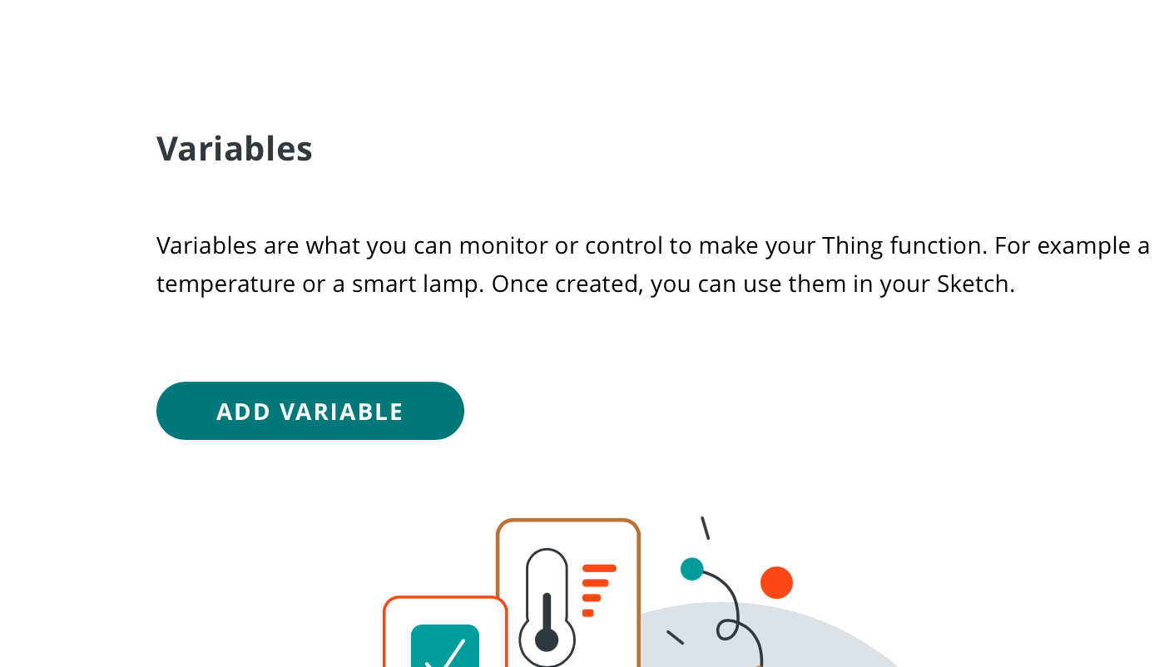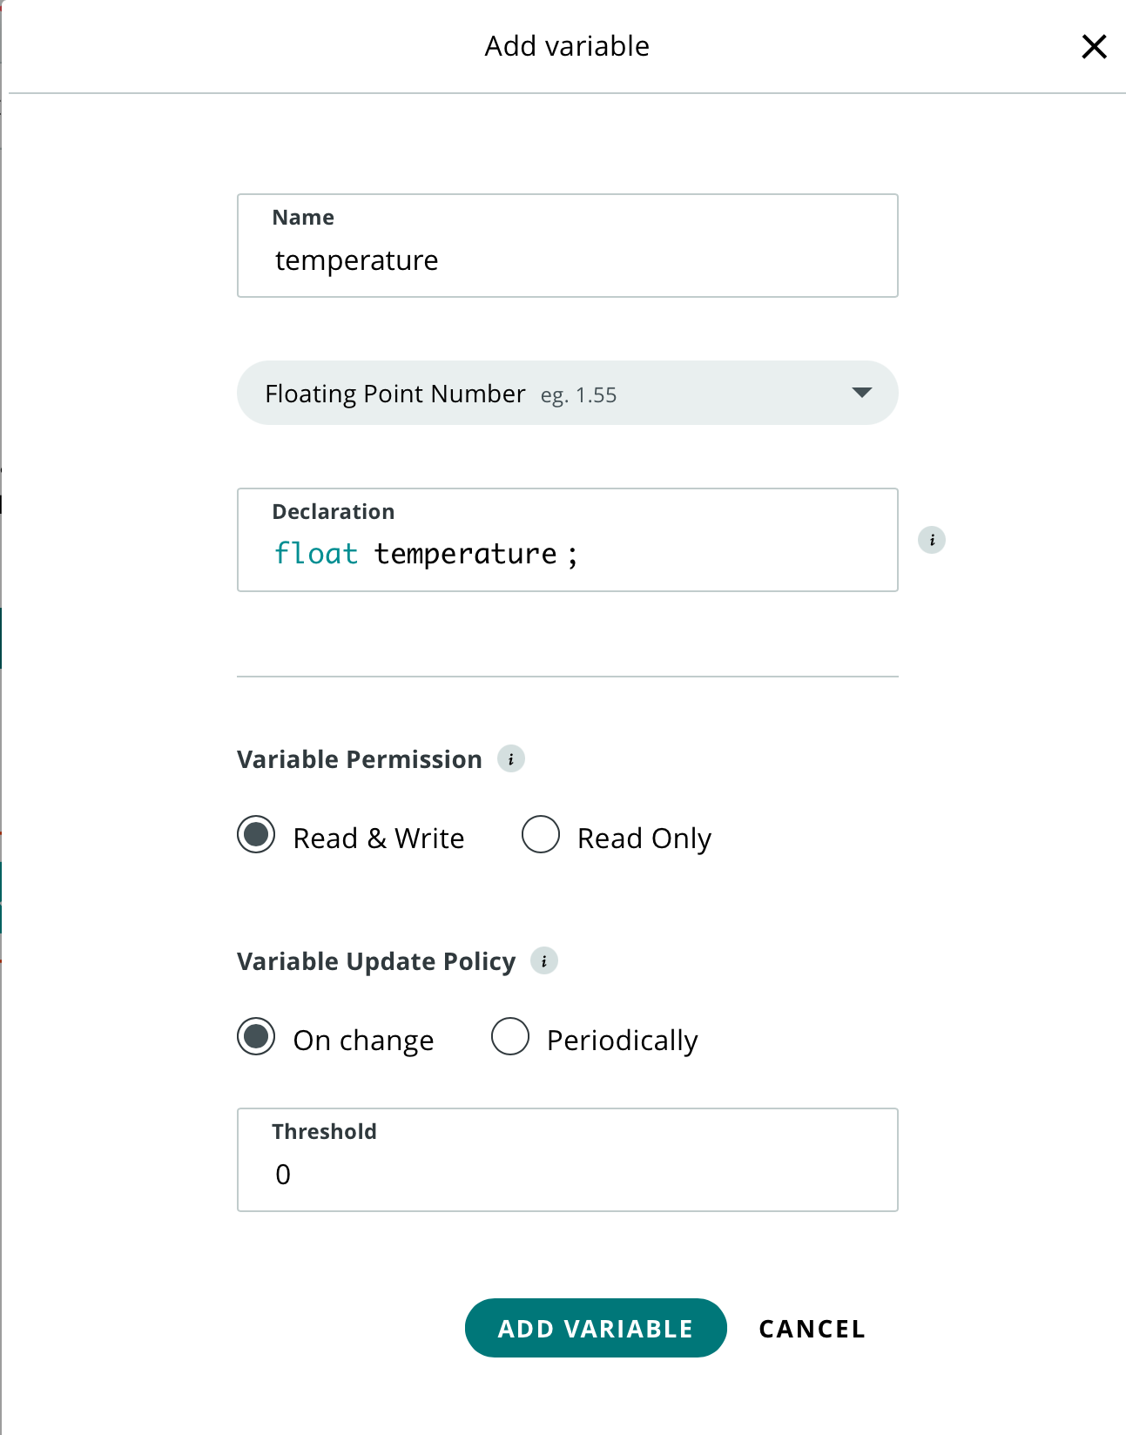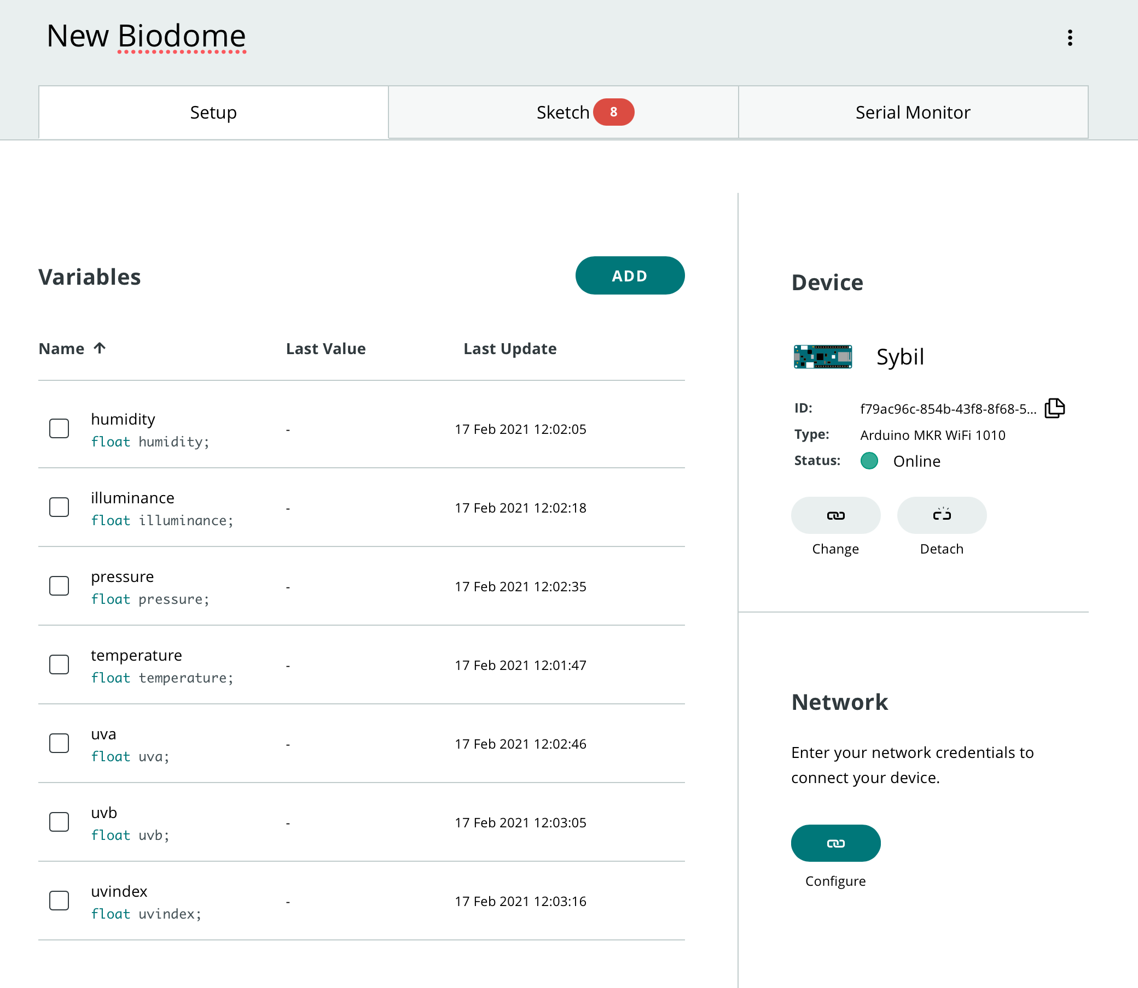

Finally, we are going to create a Boolean variable which we will use to turn the LED on and off.

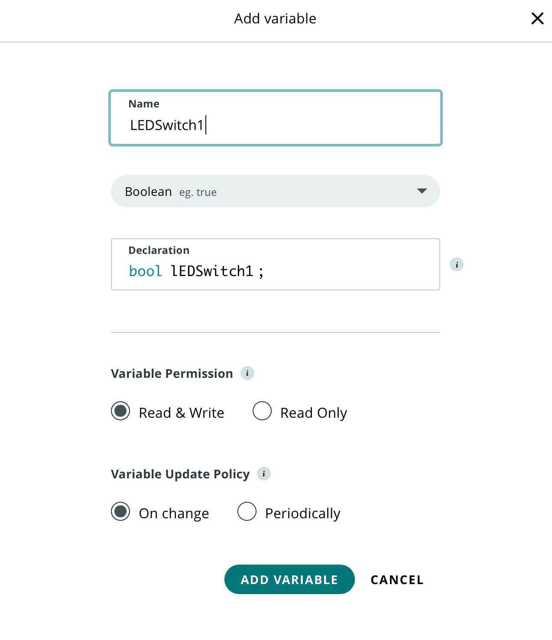

You should then click on ‘Configure under network’ and add in your network credentials.

You should now select ‘Sketch’. The next step is to combine your new thing with your code for the sensors. We are also going to add a control which allows you to remotely turn the LED on and off.

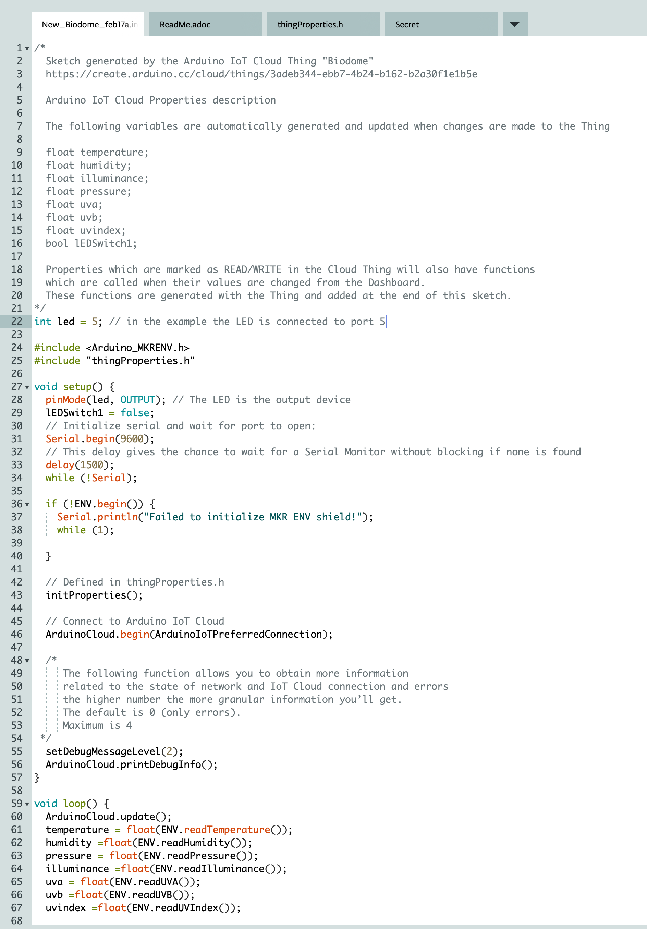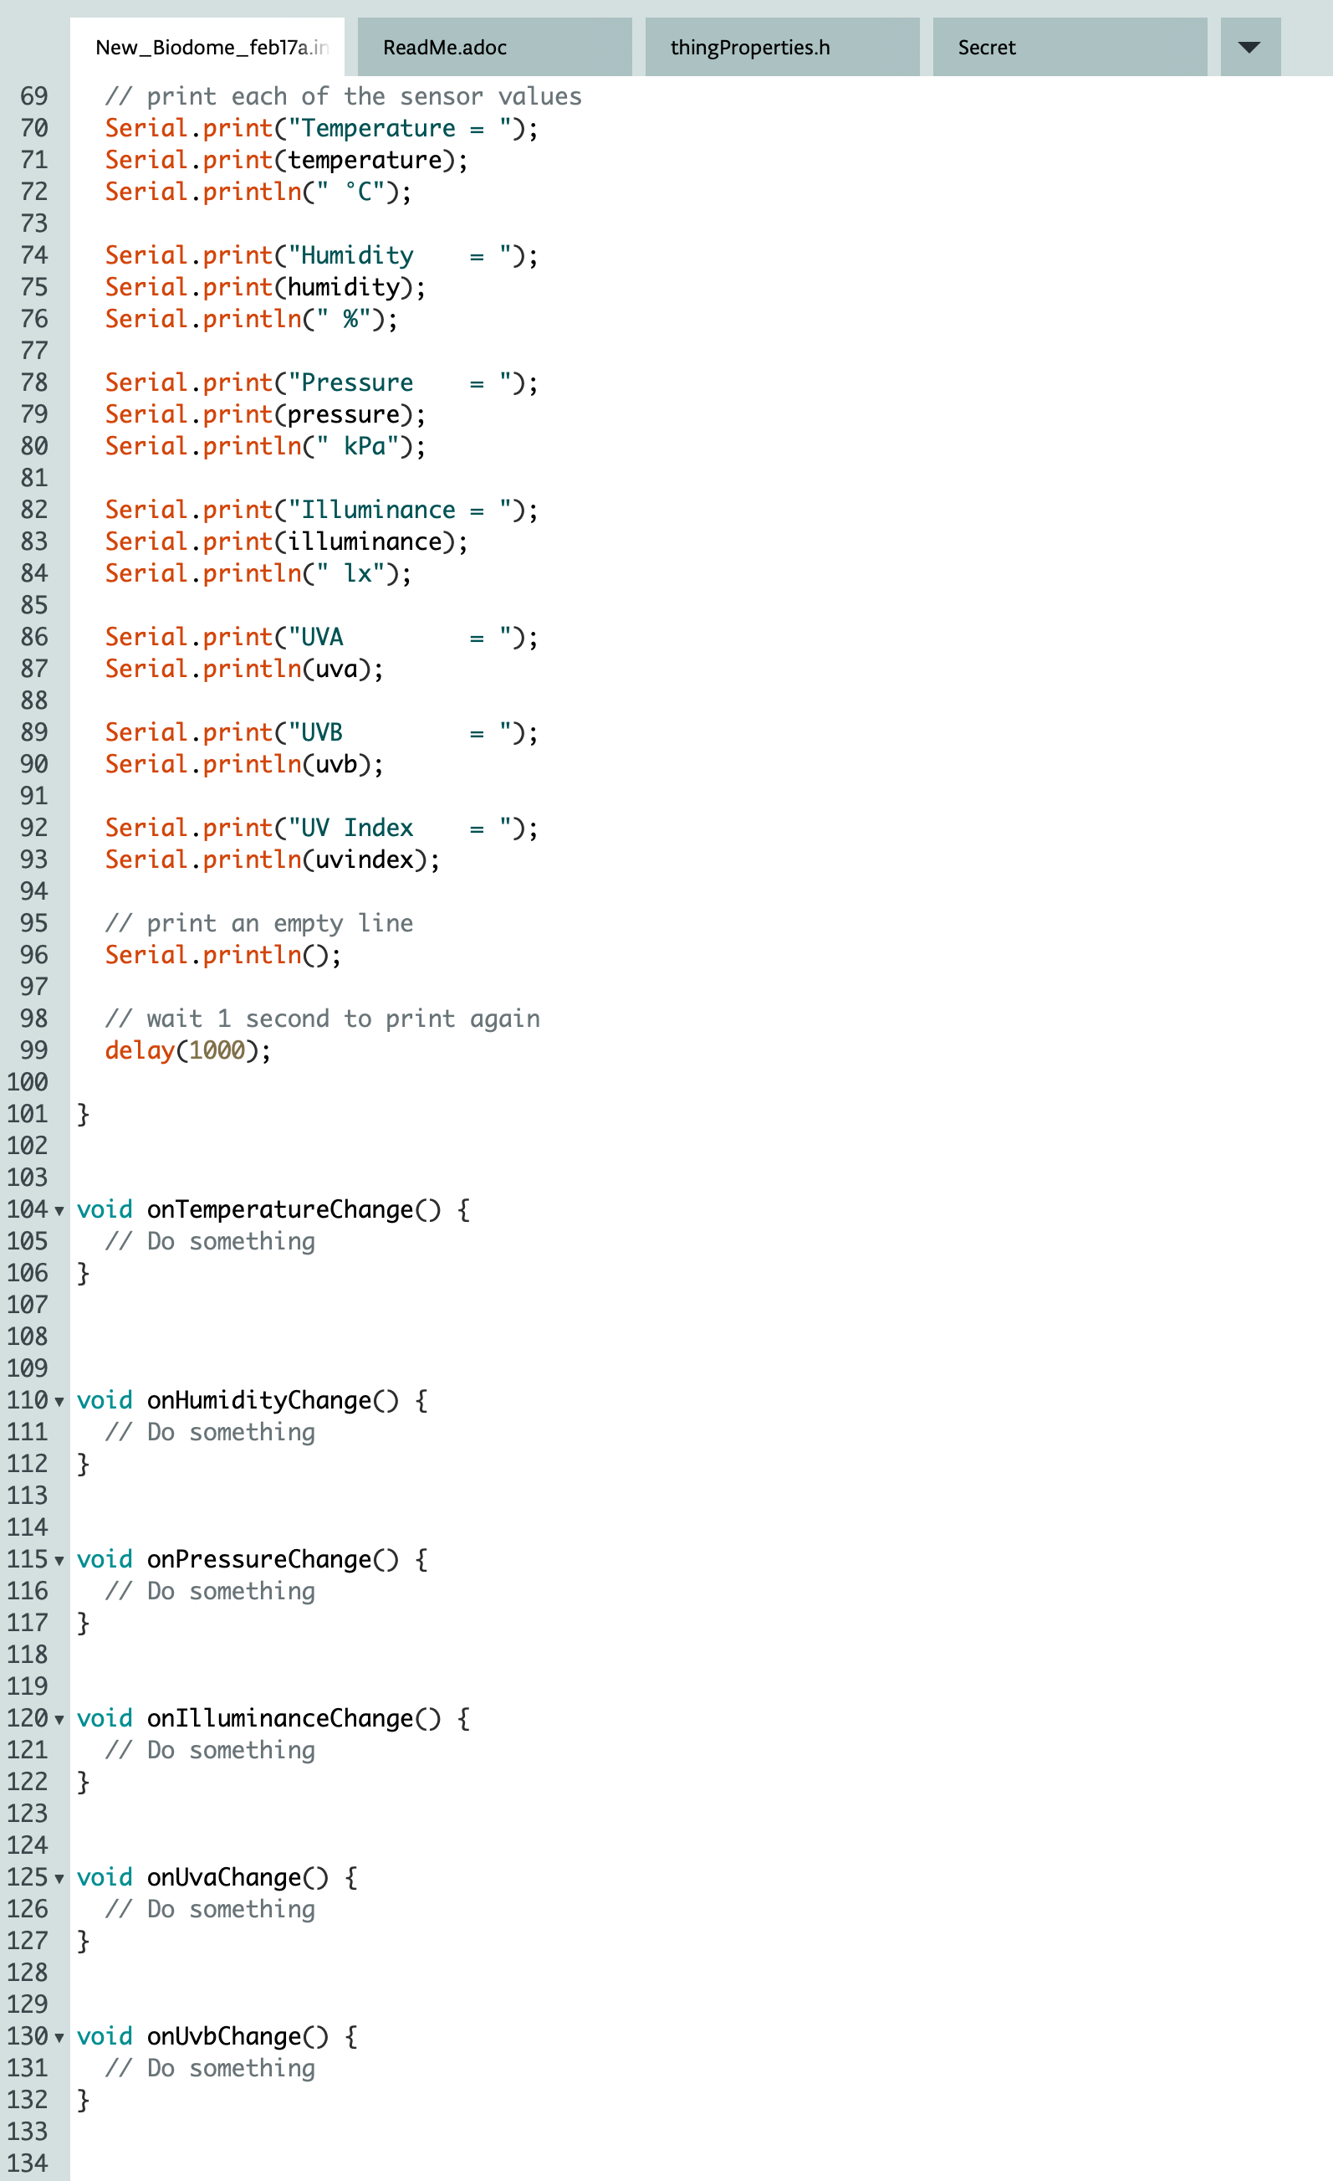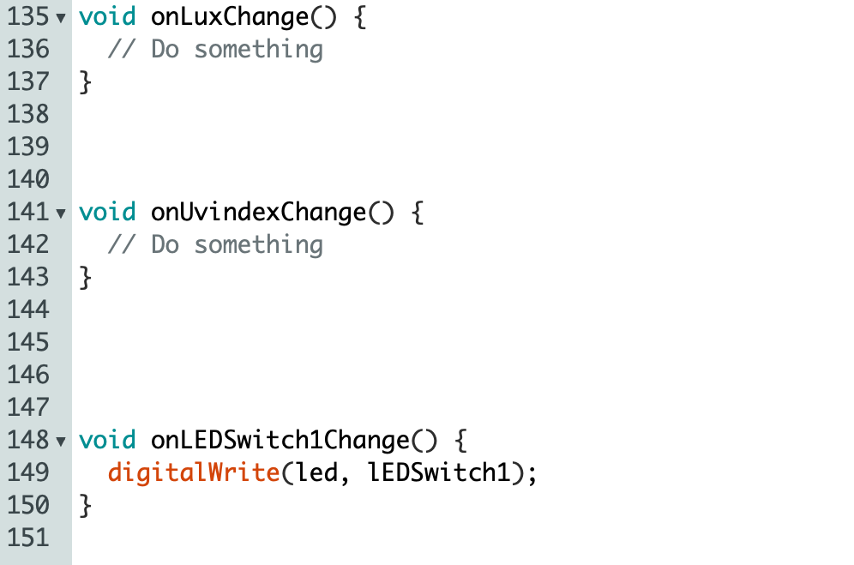

You should then check that your program works by uploading it to your device and then selecting serial monitor to check the readings that it is taking.

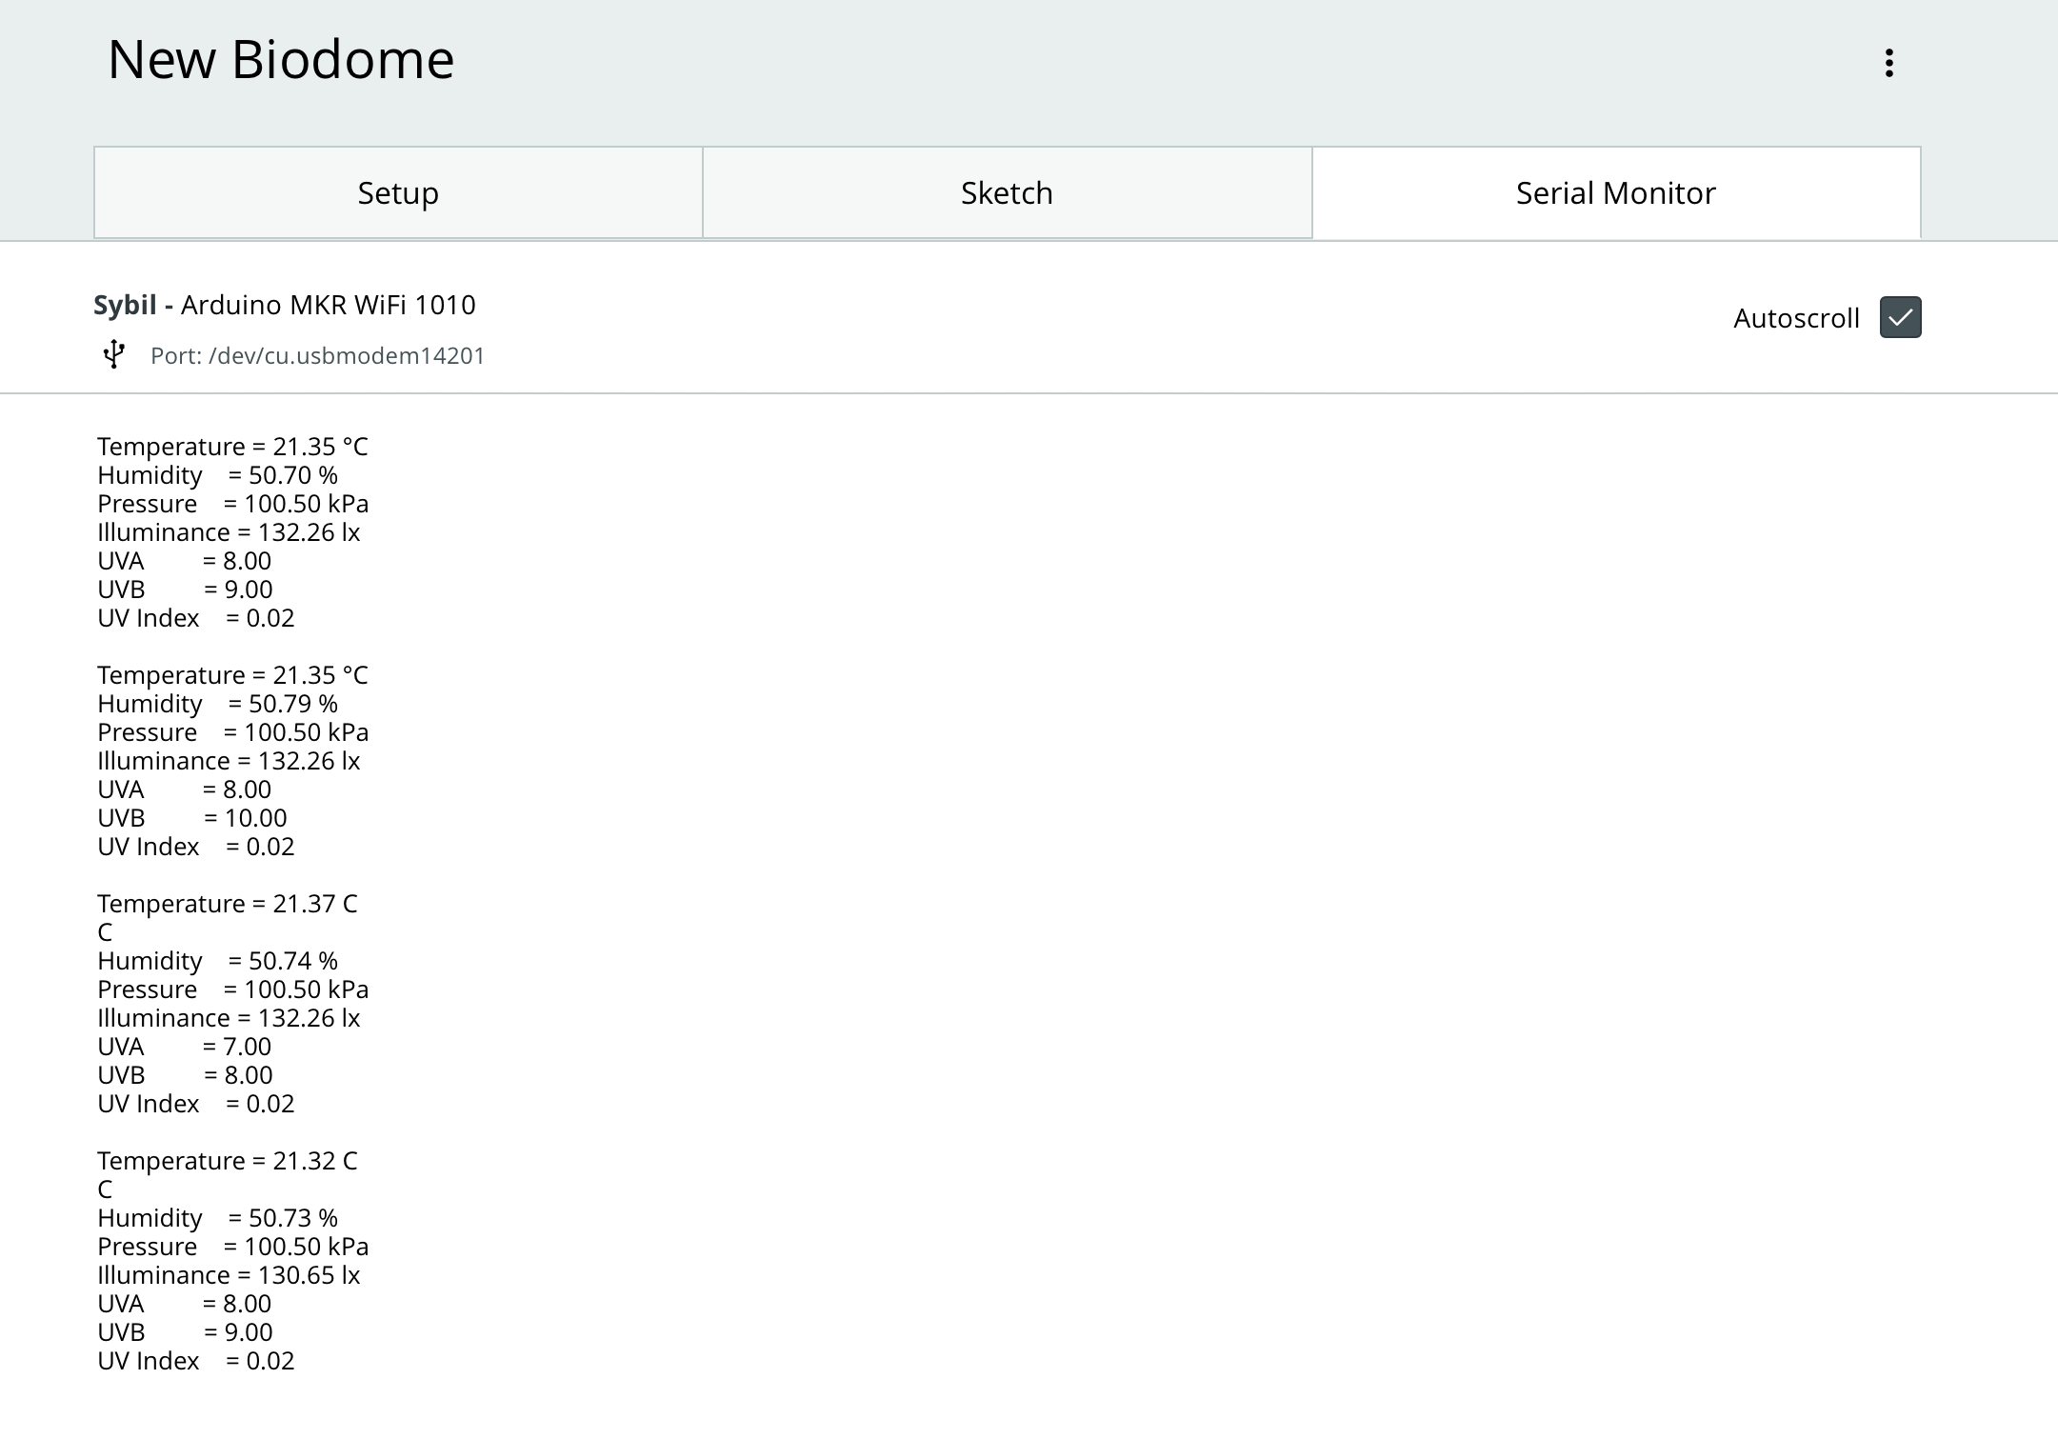

You are now going to create your dashboard. Select ‘Dashboards’ and then ‘Build dashboard’.

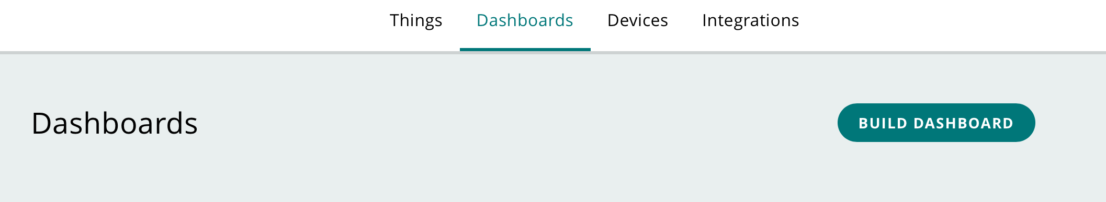

Give your dashboard a name and then select ‘Add’.

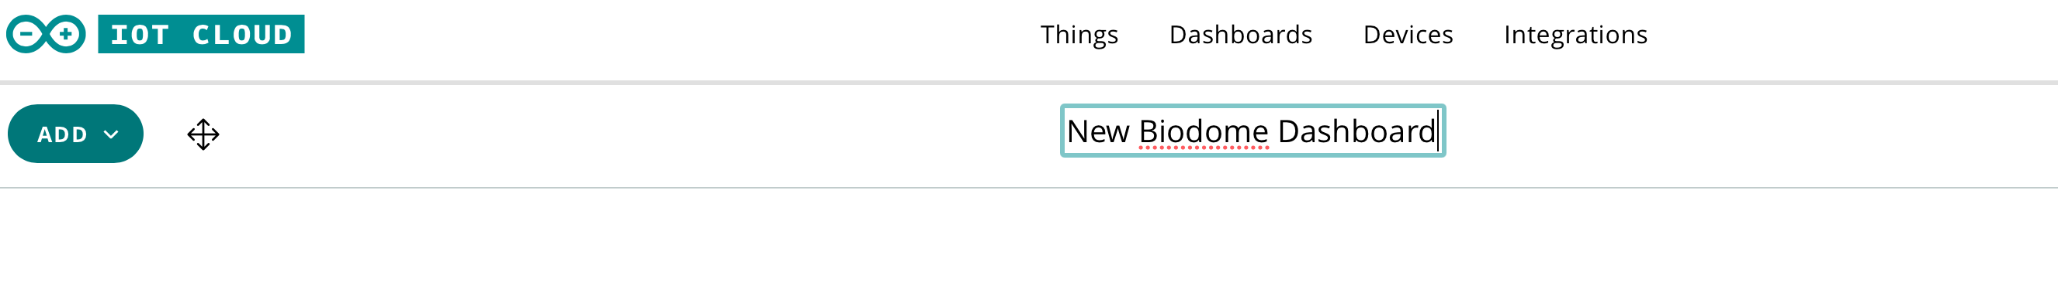

Then select ‘Things’ and choose ‘New Biodome’.

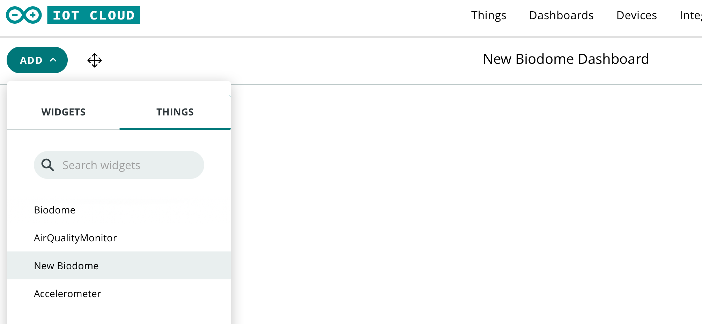

You should then click on ‘Create widgets’.

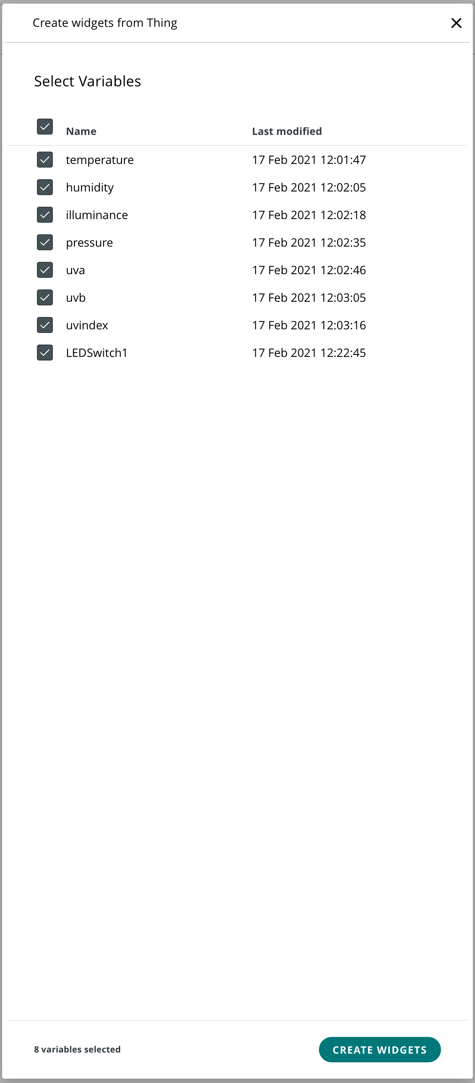

Your dashboard will then be displayed. If you click on the slider called LEDSwitch1, it will turn your LED on and off.

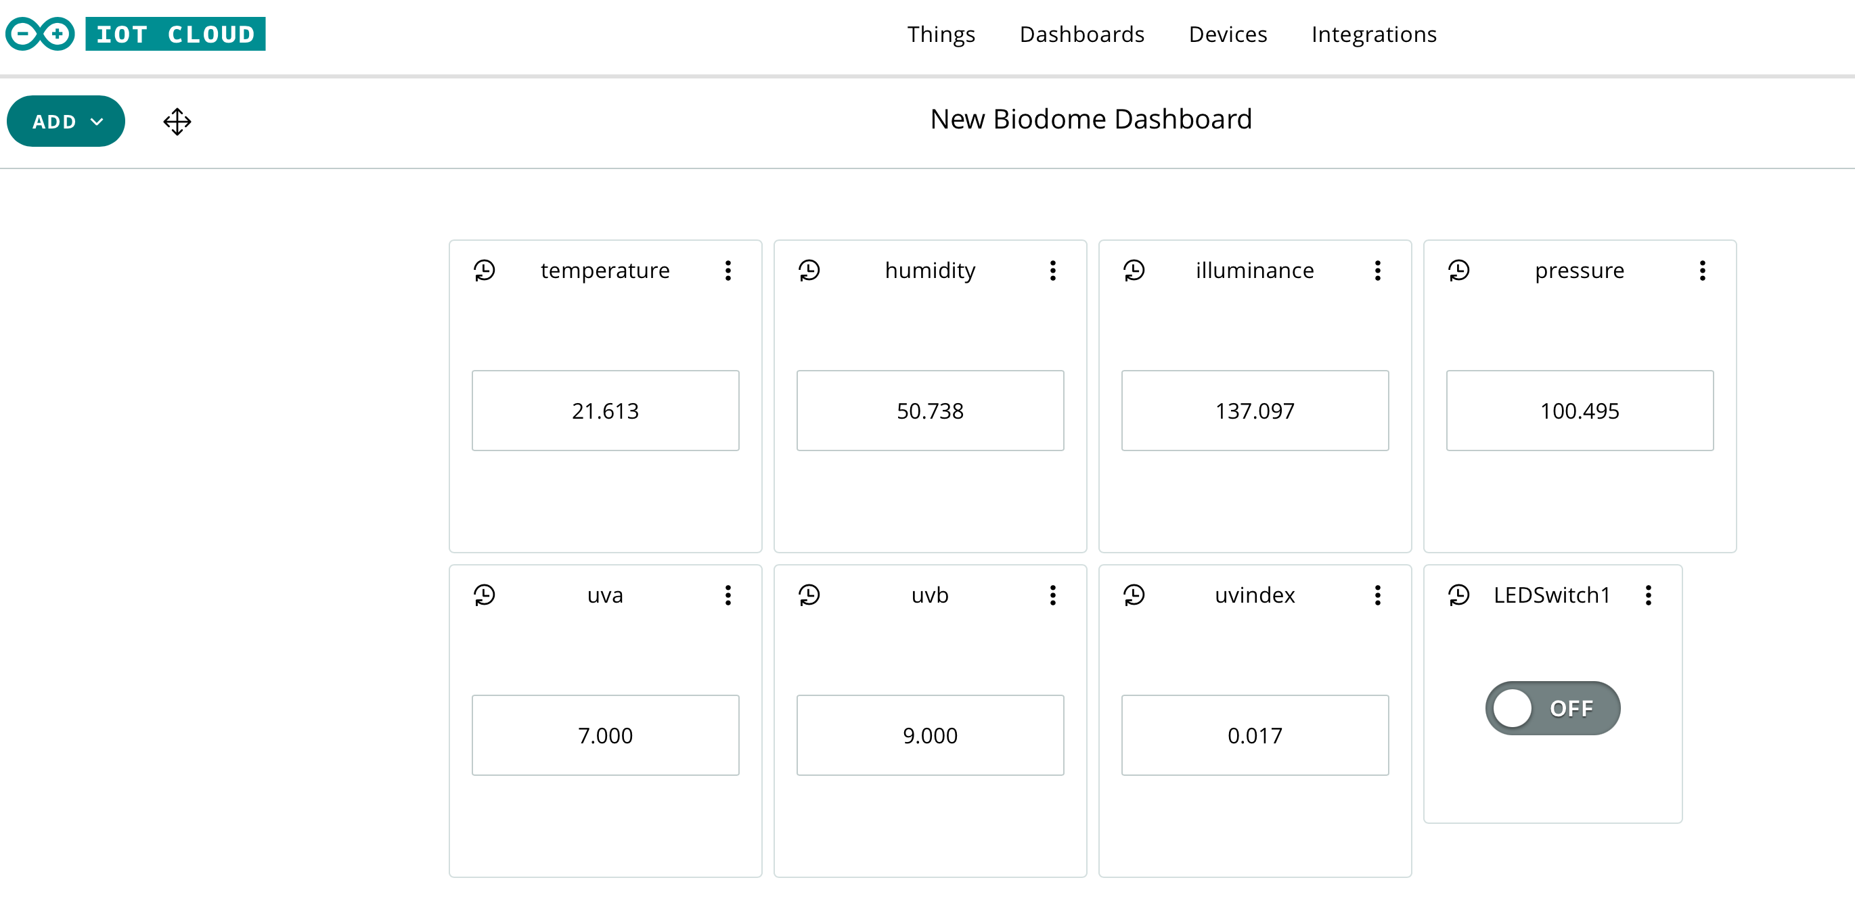

Congratulations! You have now completed the device build and programming. You can now plant your biodome and monitor the environmental conditions inside.

# Stretch tasks

Replace the LEDSwitch so that the LED automatically turns on and off depending upon ambient light levels. The following code snippet should help you.

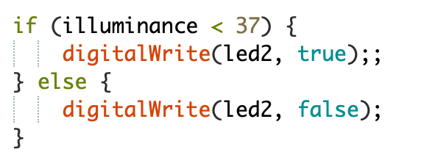

Add a motor to your breadboard with a fan blade attached. The motor should turn on and off automatically according to the readings taken by the humidity and temperature sensors. A suggested circuit diagram is included below.

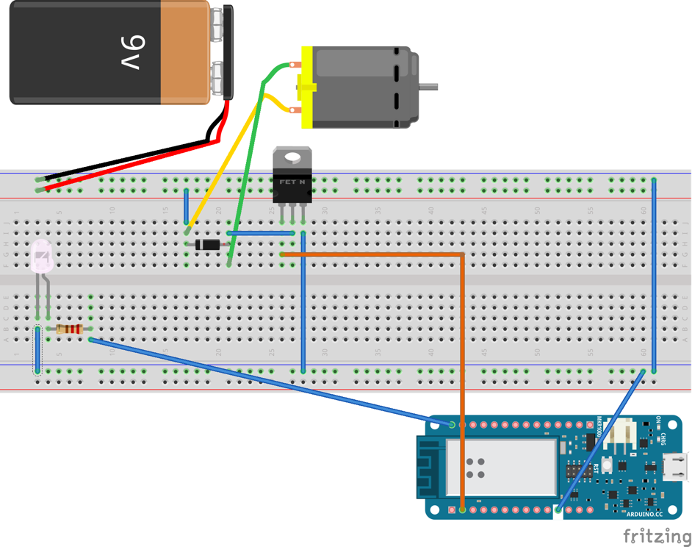

# Final thoughts

Throughout this project you have combined a range of input and output devices and have written code to process the readings from the sensors. These readings have automatically controlled a number of different output devices. Through combining sensors and output devices you are able to create a fully automated system.